**CSC 150 – Program Design Document**

**Structure Chart**

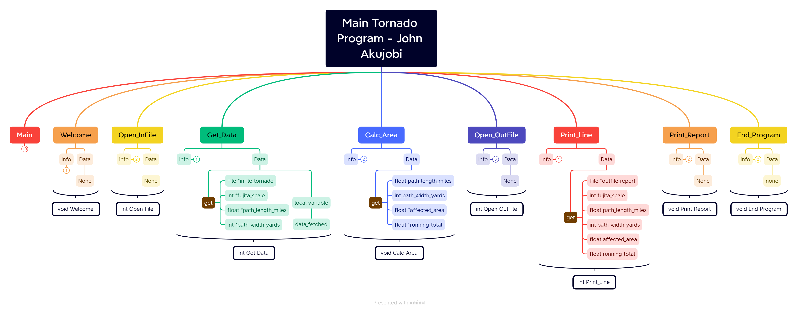

**Data Storage (Defined in Main)**

File *infile_tornado

* Pointer to Input file that holds the tornado.txt file

File *outfile_report

* Pointer to Output file that connects to Report.txt file

int fujita_scale

* first data on each line
* scale of 0 - 6

float path_length_miles

* Path length of tornado

int path_width_yards

* path_width of the tornado in yards

float affected_area

* calculated area affected by each tornado

float running_total

* the running total of affected area

### Functions ****(for each function, give the function’s prototype and 1 or 2 lines describing how the function works.)****

1. void Welcome ();
   * Prints a welcome statements and tells the user the purpose of the program
2. int Open_File (infile_tornado);
   * Opens the tornado file and reads from it
   * Prints error or success message to the terminal
   * Returns 404 if unsuccessful
3. int Get_Data (File *infile_tornado, int *fujita_scale, float *path_length_miles, int *path_width_yards);
   * It reads a line of data from the tornado.txt
   * Stores them into the pointers
   * Uses a local variable [data_fetched]
4. void Calc_Area (float path_length_miles, int path_width_yards, float *affected_area, float *running_total);
   * Calculates the area affected for each tornado and keeps a running total of the areas
   * Uses the formula [path_width_miles * path_length_yards /1760]
     + Divided by 1760 to convert the yards to miles
5. int Open_OutFile (outfile_report);
   * Creates/ Opens the Repot.txt file
   * Tells the terminal if file is successfully opened or not
   * Returns 404 if unsuccessful
6. int Print_Line (File *outfile_report, int fujita_scale, float path_length_miles, int path_width_yards, float affected_area, float running_total);
   * Prints one line into the report file
7. void Print_Report ();
   * Prints all the lines to the report and then prints the total area affected
     + While Get_Data ==1,
     + it calc Calc_Area to calculate the area
     + then calls Print_Line to print the information to the file
     + After this loop ends, it prints the Total Area to the file using variable running_total
     + Then prints a success message to the terminal
   * Prints each line to the terminal to let user know the progress
8. void End_Program ();
   * Closes the two files
   * Prints an exit message to the terminal to signify the end of the program